**Project report:**

Project title: vehicle management system using Salesforce

1.Introduction

1.1 Overview

vehicle management is an application A customer detail are store for travel within the city.

1.2Purpose

The purpose of vehicle management is to track and manage the activities Unconditional of vehicles such as track,carUsing digital means. this helps transportation business keep abreast of How the vehicle perform given them items on how to the usage.

2 Problem Definition and design thinking

2.1 Empathy map

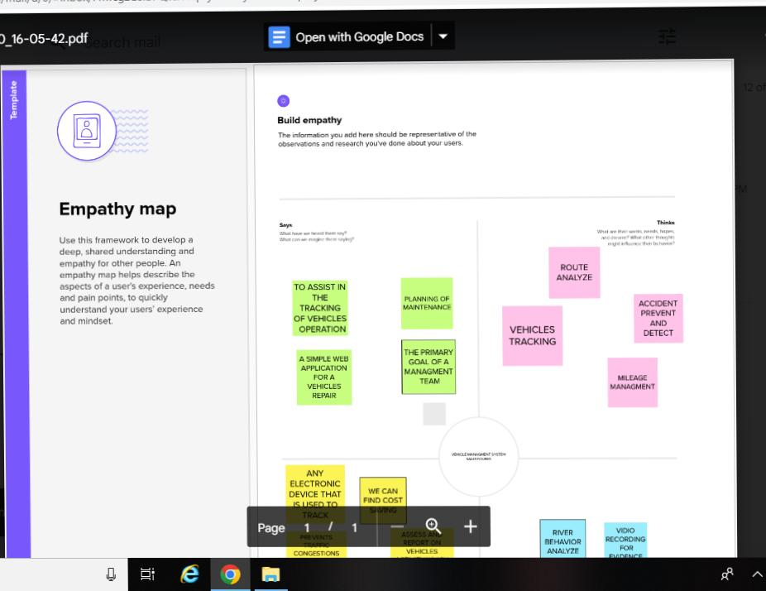

2.2 Ideation and brainstorming map

3 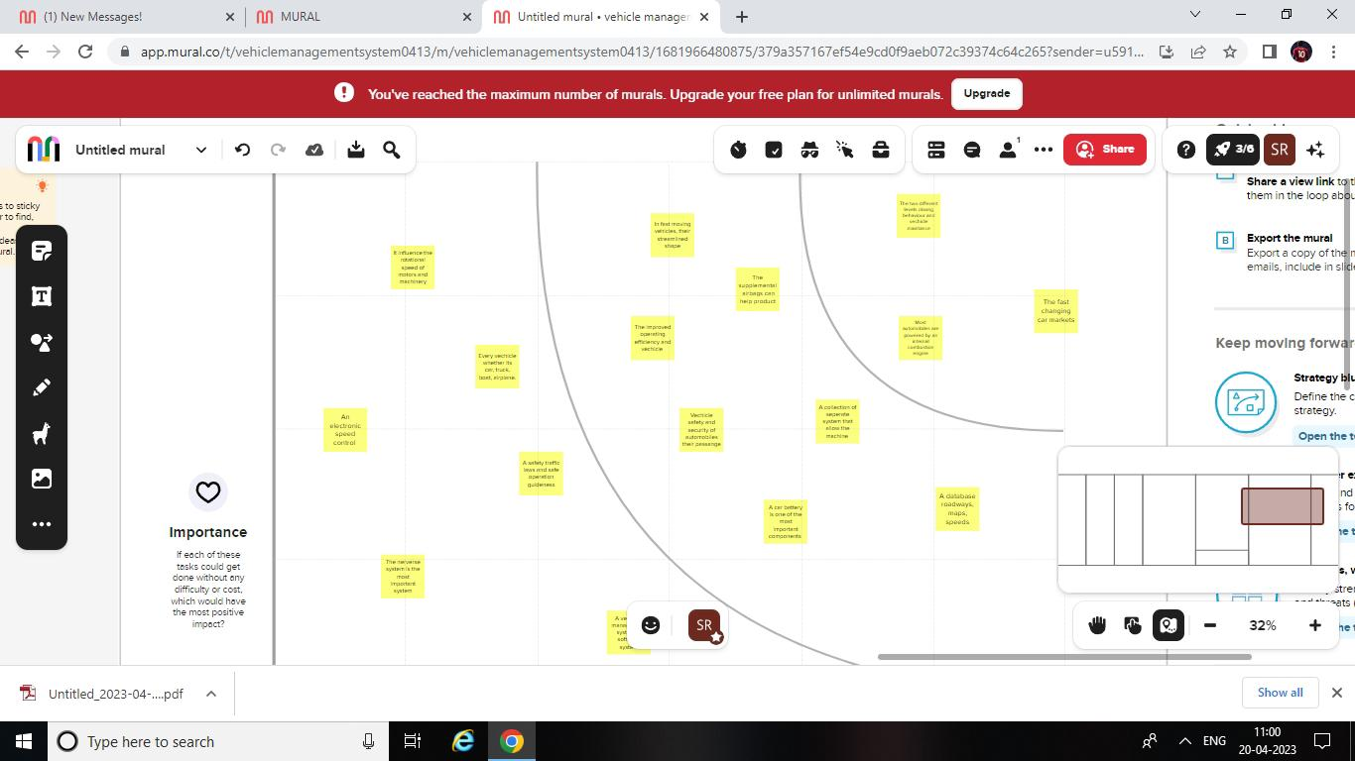Result

3.3 Data model:

|  |  |  |
| --- | --- | --- |
| *Object name* | *Field in the object* |  |
| *company name* | *Fire label* | *data type* |
|  | *Toyota* | *text* |
|  | *Tata Motors* | *text* |
|  | *Mahindra* | *text* |
| *vehicle condition vehicle* | *Good* | *text* |
|  | *medium* | *text* |
|  | *least* | *Text* |

*3.2 Activity and screenshots*

*1.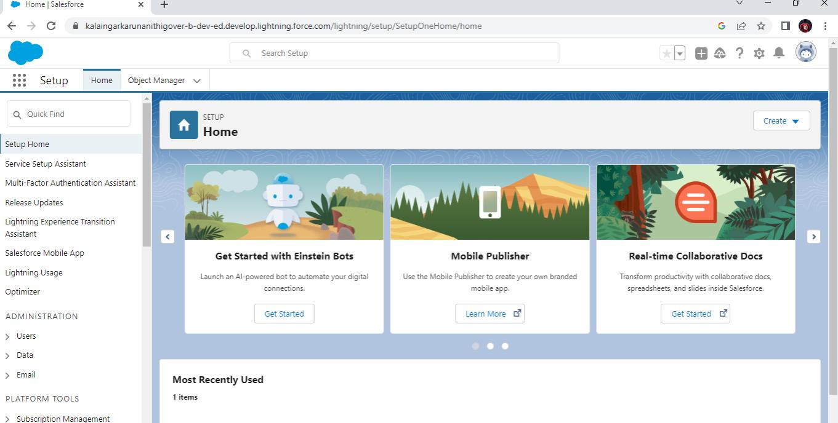Login to Salesforce.com*

*2.After logging this is the homepage which you will see*

*1.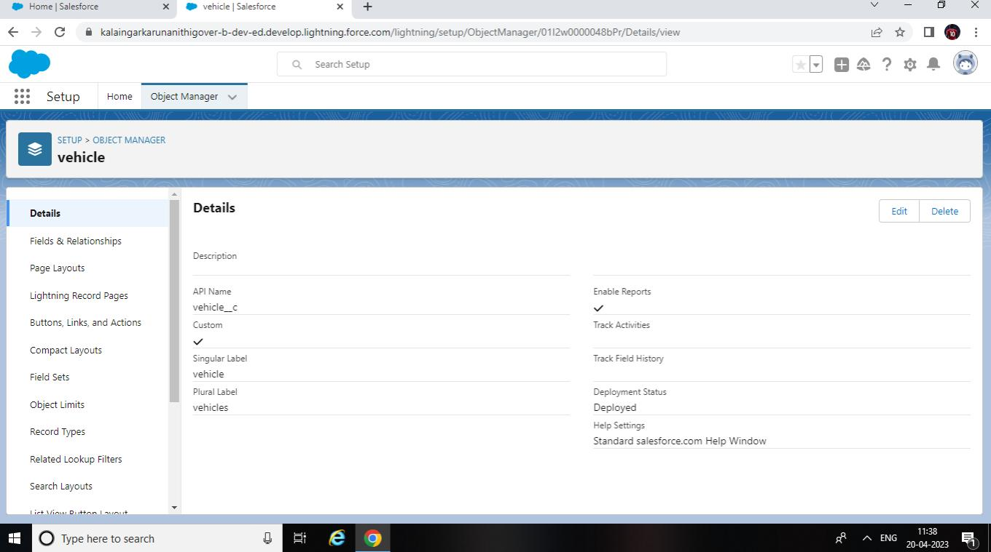Click the object manager*

*2.select create and customer object*

*3.Create your object*

*1. Go to the object manager unselect filed and relationshipAnd lightning experience app management*

*1.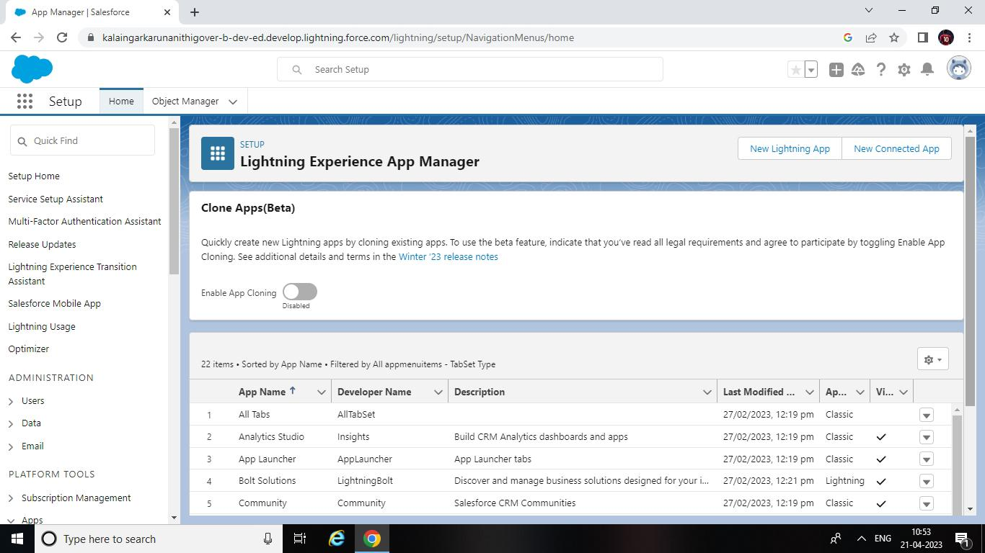Create your filed*

*Search to select You say create your user*

*1.Secelet to report type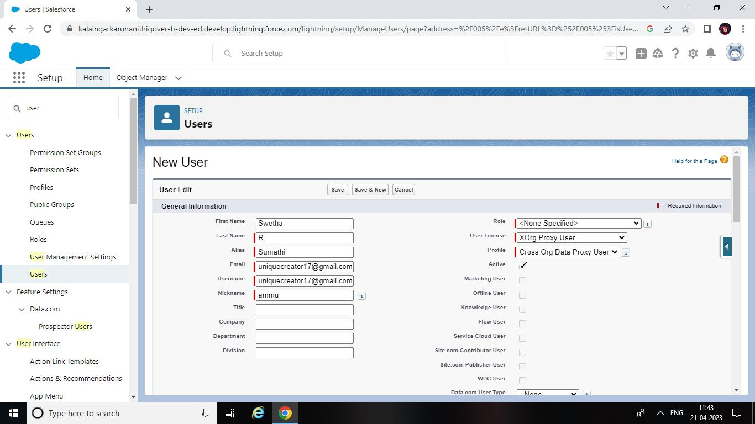*

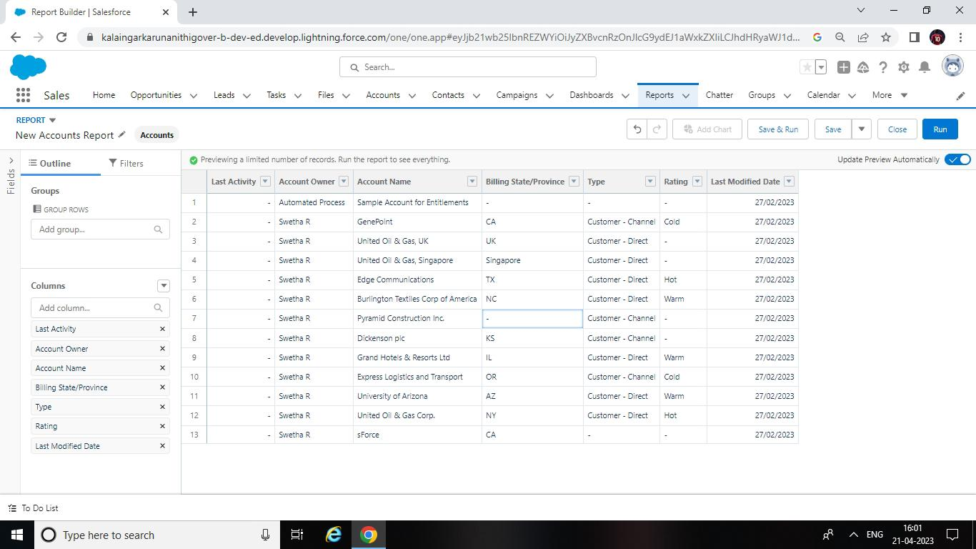

*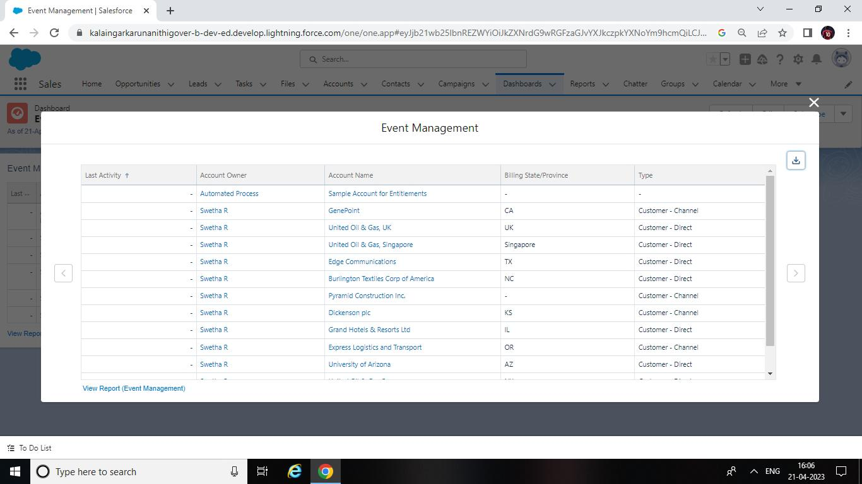Create your report type*

*Trailhead profile public UR*

*Team leader:* [*https://trailblazer.me/id/swetr30*](https://trailblazer.me/id/swetr30)

*Team member 1:* [*https://trailblazer.me/id/ssumathi13*](https://trailblazer.me/id/ssumathi13)

*Team member 2:* [*https://trailblazer.me/id/ssankari19*](https://trailblazer.me/id/ssankari19)

*Team member3:*[*https://trailblazer.me/id/mveerasakthikthi*](https://trailblazer.me/id/mveerasakthikthi)

*5.Advantage and disadvantage:*

*\*duplication of the vehicle data is avoid*

*\* timely alright ensure that penalties are avoided*

*6.Applications:*

*\*vehicle management system customization*

*\* vehicle management system integration*

*7.Conclusion :*

*in this system the transport management designing and development a lost cost system based on integration of GPS and XP data is described*

*8.Future scores :*

*The future of the smart parking system is expected to be signification influenced by the arrival of the automator vehicles several cities around the world are already beginning to tribal selfparking vehicles special And robotic parking valet.*